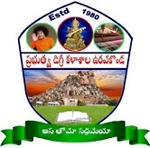 GOVERNMENT DEGREE COLLEGE: URAVAKONDA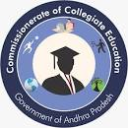

**DEPARTMENT OF CHEMISTRY**

|  |  |  |
| --- | --- | --- |
| **S.NO.** | **DESCRIPTION** | **VIEW DOCUMENT** |
| **1** | **CBCS wef 2015-16** | [**CLICK HERE**](https://gdckandukur.ac.in/userfiles/bscchem%202015-16.pdf) |
| **2** | **CBCS wef 2016 (ELECTIVES)** | [**CLICK HERE**](https://gdckandukur.ac.in/userfiles/bscchem%202016.pdf) |
| **3** | **CBCS wef 2020-21** | [**CLICK HERE**](https://gdckandukur.ac.in/userfiles/bsc_chemistry_cbcs_2020.pdf) |
| **4** | **SEM 5 SKILL ENHANCEMENT COURSES** | [**CLICK HERE**](https://gdckandukur.ac.in/userfiles/Chemistry%20SEM-5.pdf) |